**1001L**

**PROGRAMMING FUNDAMENTALS**

**Café Anteiku: Management System**

**Project Report By**

**Sana Muhammad Yousuf (BSSE 1A1)**

**Group Members:**

**Sana Muhammad Yousuf SE202002**

**Table of Contents**

1. Introduction 3

2. Scope 3

3. Module Description 3

4. Hardware/Software Requirements 3

5. Screen Shots 3

6. Architecture Diagram 3

# Introduction

This project is a Management System for Café Anteiku. The system makes the café staffs job easier as it automates customer activities like order taking and receipt generation, as well as helping staff serve orders on the customer’s request. The Café staff and owners can log in to view inventory, restock items as needed and also access a log of well-organized sales records.

# Scope

With this project I aimed to deliver a management system capable of handling tasks on both the customer and employer end, and that was achieved.

This program is capable of taking a multiple item order from a customer, generating a receipt and serving the order while making use of flags such as e.g. Serve Order -> “Place an order first”. To log into the admin system user has to enter the correct username and password. Once successfully logged in the employee can view stock, restock and view all orders.

The user is able to make choices through switch case statements and I employed the use of multiple separate functions for the tasks to make my code more readable and aesthetic. The program makes use of some global variables such as “name” and “total cost” so that these are accessible throughout the program.

One thing I am particularly proud of is storing data to two different files for different purposes in this program! The receipt is generated when the “currentOrder” file is read and this is later overwritten with each new order placed, while the “allOrders” file displays all orders placed!

# Module Description

This program is divided into two main modules:

1. Customer Panel:

This module lets the user choose from multiple customer choices such as place order, view order, serve order and exit to main menu.

Place order displays a menu that contains caffeine beverages and dessert, the user can choose items and their quantity and order multiple items at a time. These choices are saved to file.

View Order generates customer receipt that by reading from file.

Serve Order serves existing order.

All the choices in this module have proper flags.

1. Admin Panel:

This module lets an employee log in and manipulate stock and view logs.

The log in username and password is authenticated by using “strcmp” which compares the inputs to already defined strings.

View stock showcases a list of all the items left in stock, these item quantities are stored in an array.

Restock sets the value of each element of the array back to the initial value i.e.50.

View orders of the day reads from all orders file and displays all the orders palced.

# 4. Hardware/Software Requirements

Any Windows/MacOS/Linux system is capable of running this simple program.

C language is used- Library files <stdio.h> and <stdlib.h> used.

This Program was developed on Dev C++

# 5. Screen Shots

Program Start- Main Menu /Choosing Customer Panel and Place Order

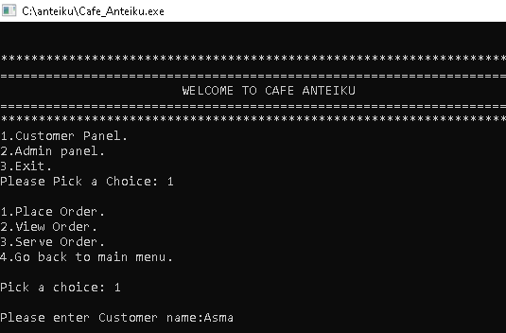

Customer enter name and placing order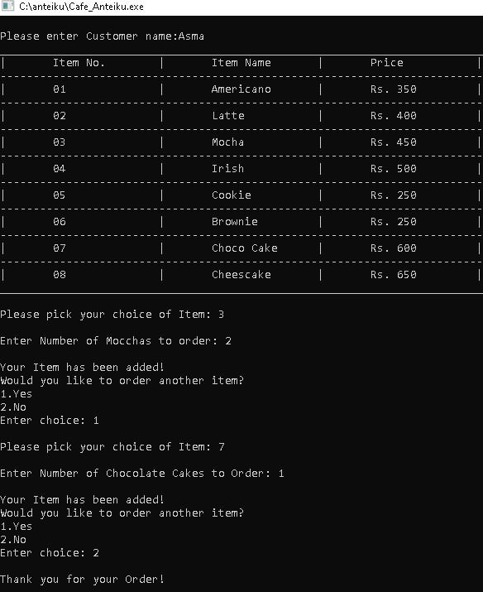

Customer View order(receipt) and serve order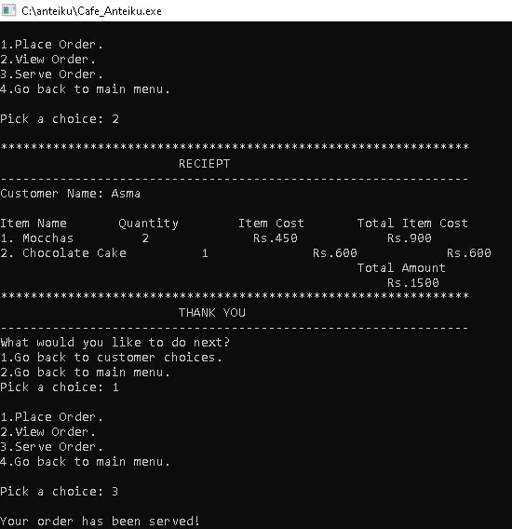

Choosing Admin Panel/ Login/View Stock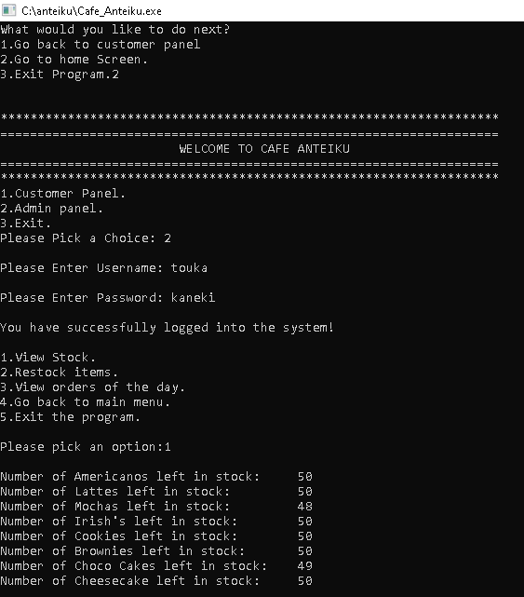

Restock and View Log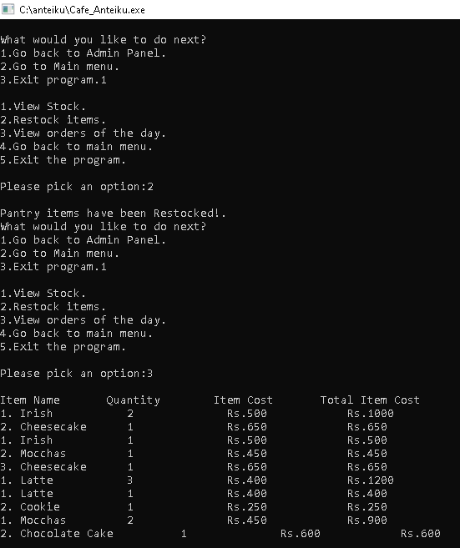

This is the file that generates receipt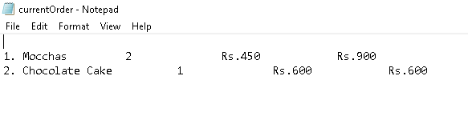

This is file that has all order records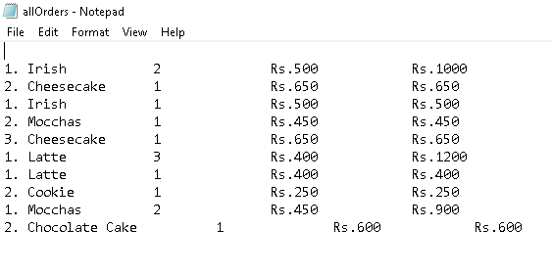

# 6. Architecture Diagram

